ADA LAB (Assignment-1)

Task 1: Algorithm Growth Observation Write Python programs to implement the following functions:
- Constant Time : O(1)
- Linear Time : O(n)
- Quadratic Time : O(n2 )
- Logarithmic Time : O(log n)

Steps
  - Measure execution time for different input sizes (e.g., n = 10, 100, 500,
1000).
  - Plot Input Size vs Execution Time.
  - Observe and comment on the growth pattern.

Deliverables
  - Python script or notebook
  - Execution time plots

Code-
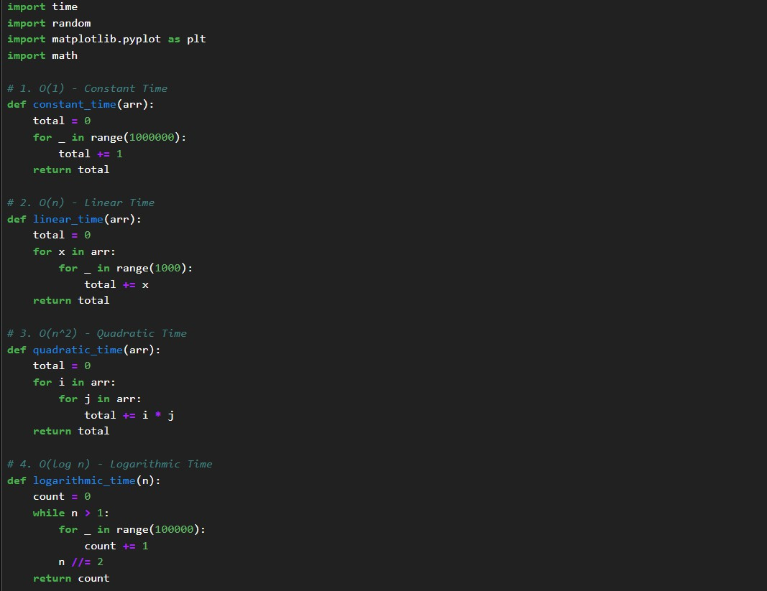
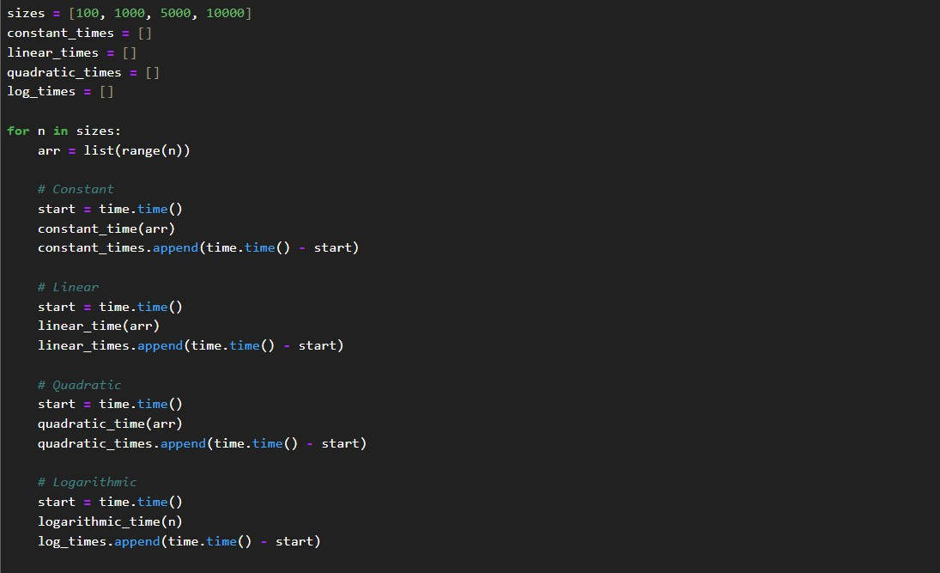
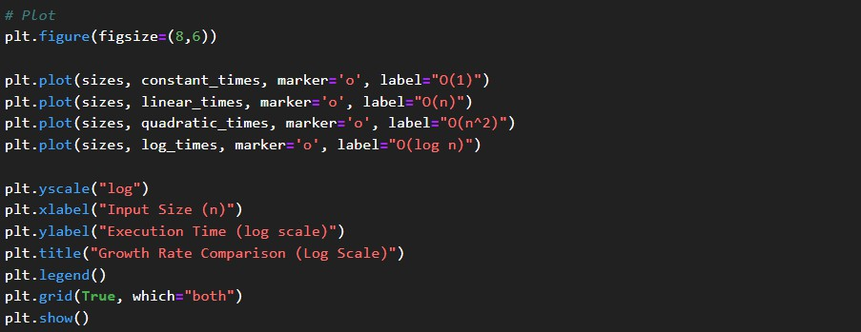

Output-
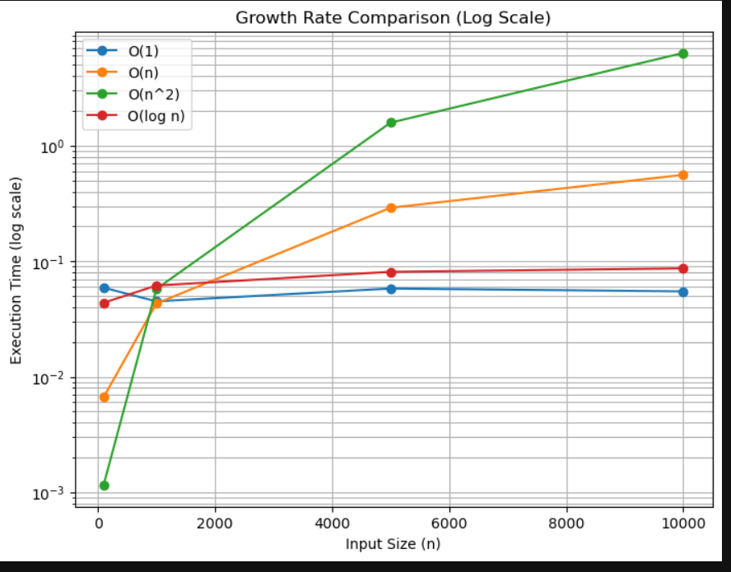

Task 2: Best, Average, and Worst Case Analysis
Implement Linear Search and Binary Search. Requirements
  - Generate random arrays of different sizes.
  - Measure execution time for:
- Best case
- Average case
- Worst case
  - Compare results using plots.

Deliverables
  - Search algorithm implementations
  - Comparison plots
  - Observations in comments/markdown

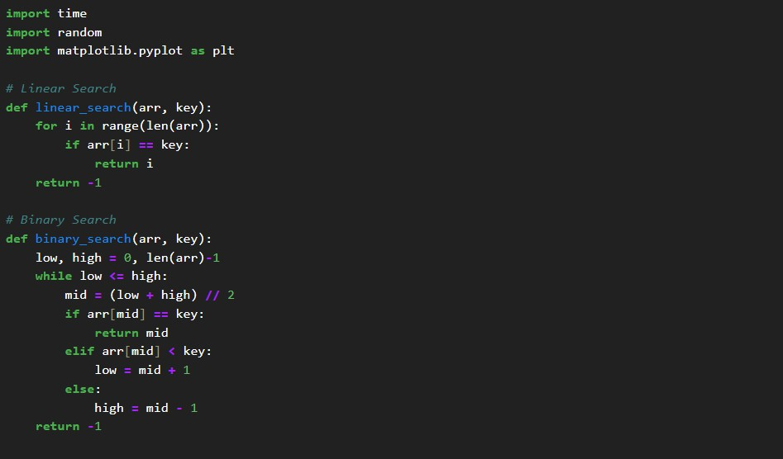
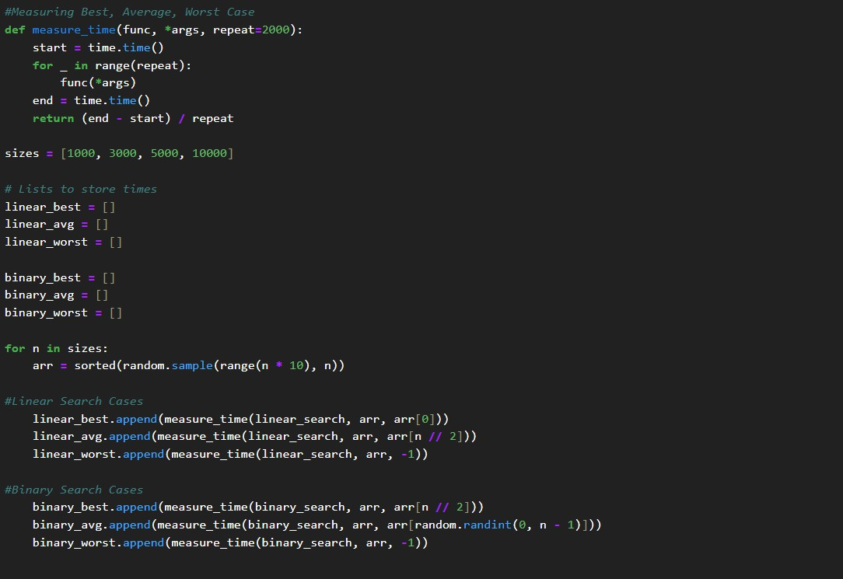
Code-

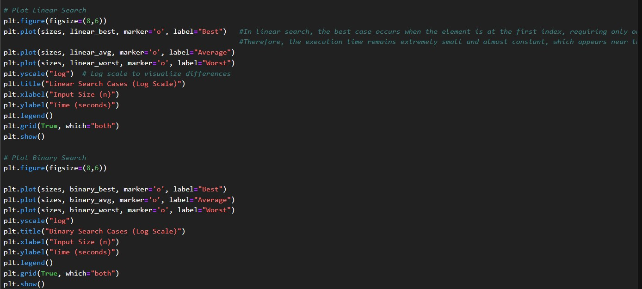

Output-
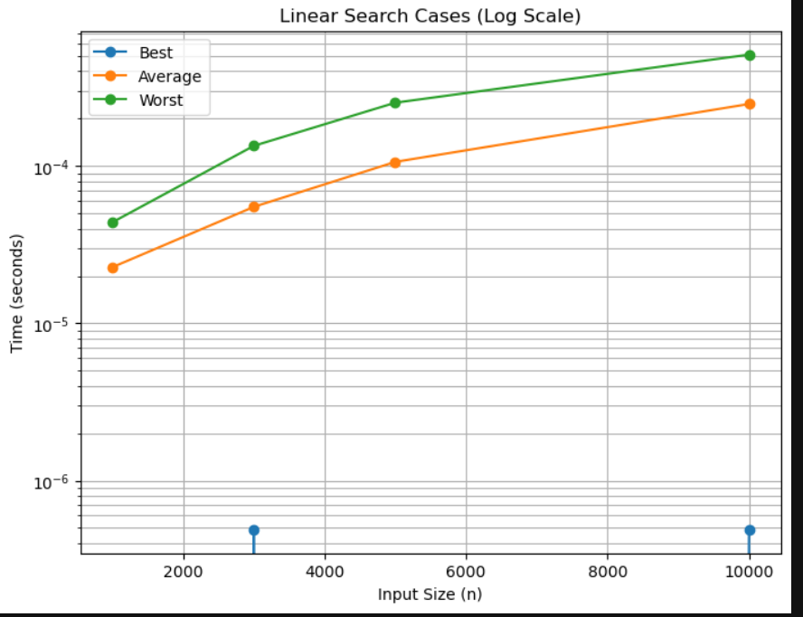
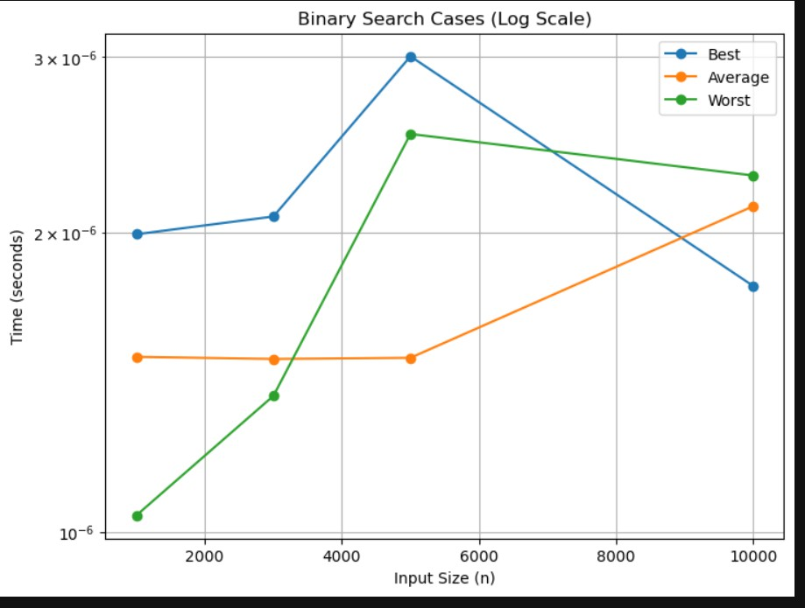

Task 3: Recursion and Recurrence Validation
Implement the following recursive algorithms:
- Factorial
- Fibonacci (Naïve Recursive)
- Fibonacci (Dynamic Programming)

Steps
  - Count number of function calls for each input size.
  - Measure execution time.
  - Compare recursive vs optimized approach.

Deliverables
  - Python implementations
  - Table comparing execution time and function calls

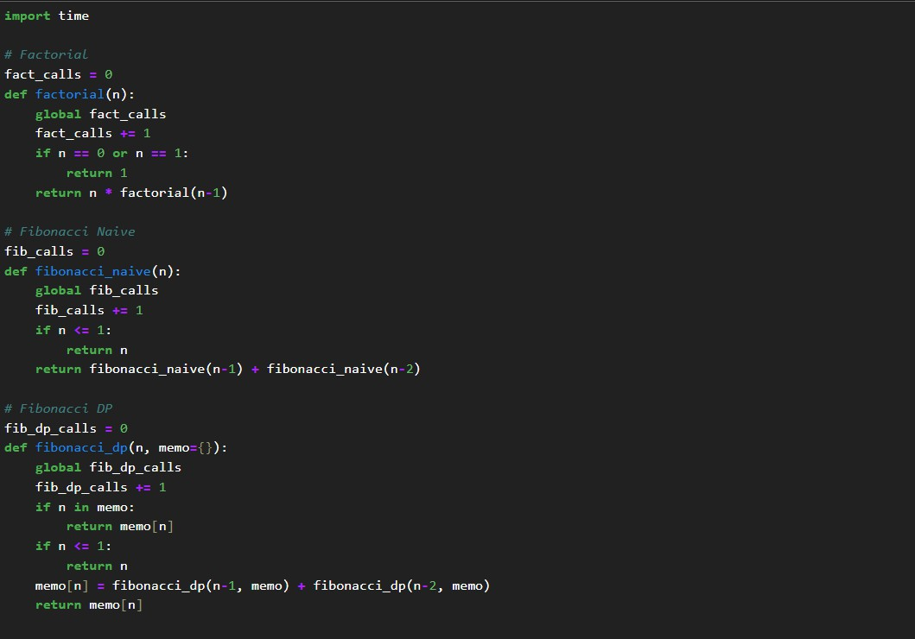
Code-

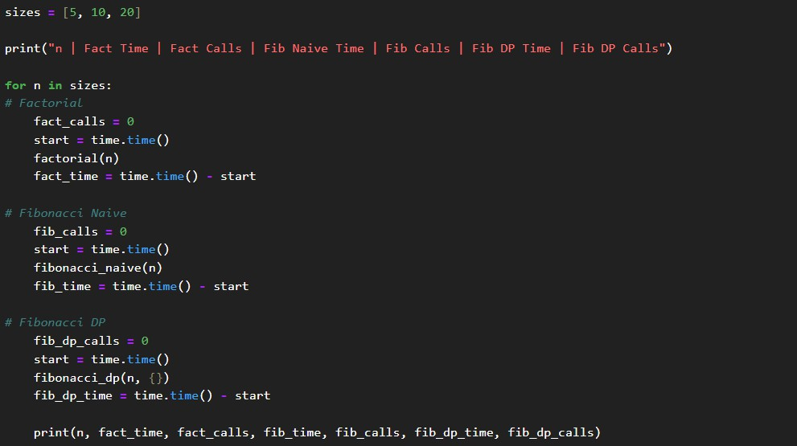

Output-
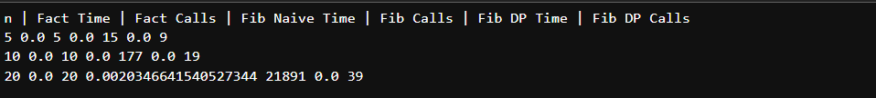

Task 4: Solving Recurrences through Code Implement recursive functions corresponding to these recurrences:
- T(n) = T(n/2) + n
- T(n) = 2T(n/2) + n

Steps
  - Count recursive calls.
  - Measure execution time.
  - Validate results with expected asymptotic complexity.

Deliverables
  - Code with call counters
  - Observational comments

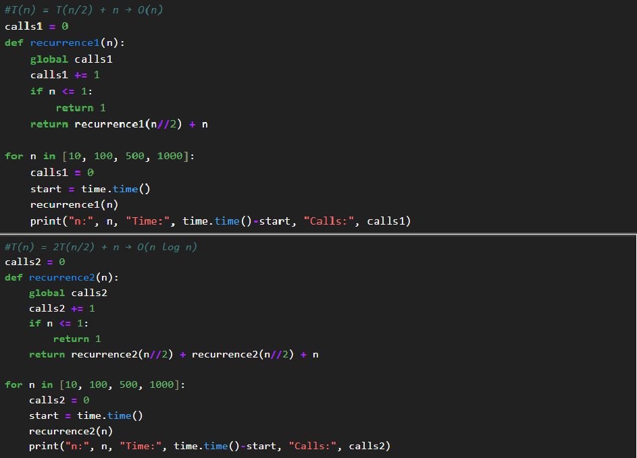
Code-

Output-
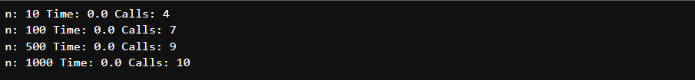
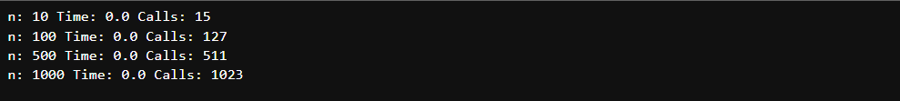

GitHub Repository Link: https://github.com/Aryaveersingh14

